H3 PLUS Firmware Update Procedure
- This device requires firmware version 1.0.26 or higher.
- Plug the Type-C end into the H3 Plus and the USB end into the computer. Then press and hold the PTT button and the “3” key to power on. The H3 Plus will automatically enter the firmware upgrade interface, and the computer will recognize the USB device.
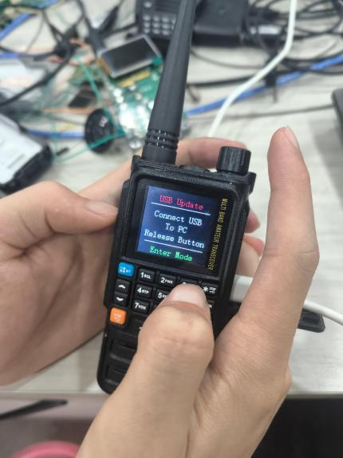
- Then Open Update App.exe, change the "Language (L)" in the upper left corner to English.
Click "Open" and select the "xxx.fw" file. Click the “Reset after successful update” option, then click Upgrade.
